Truncated Cube
# Source: AI Source: Provided by: [Data Path: Persons Table -> ID Column: 1, Name_En Column: Motasem Essam] -> From: [ChatGPT] on [7/25/2026]
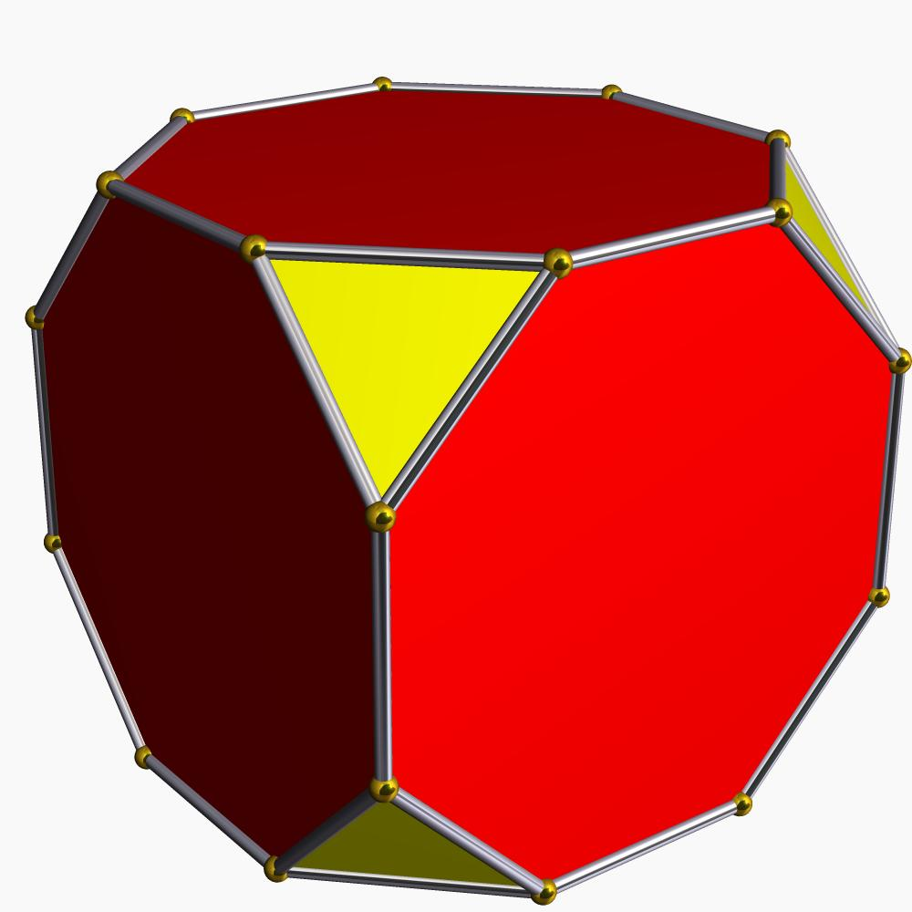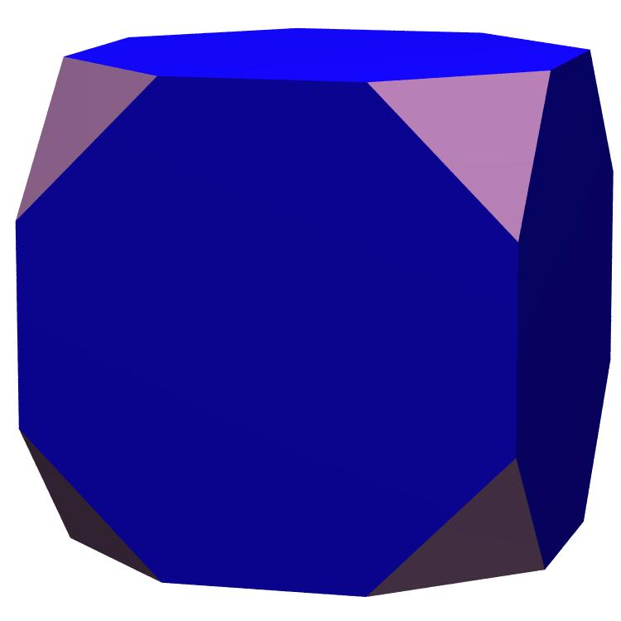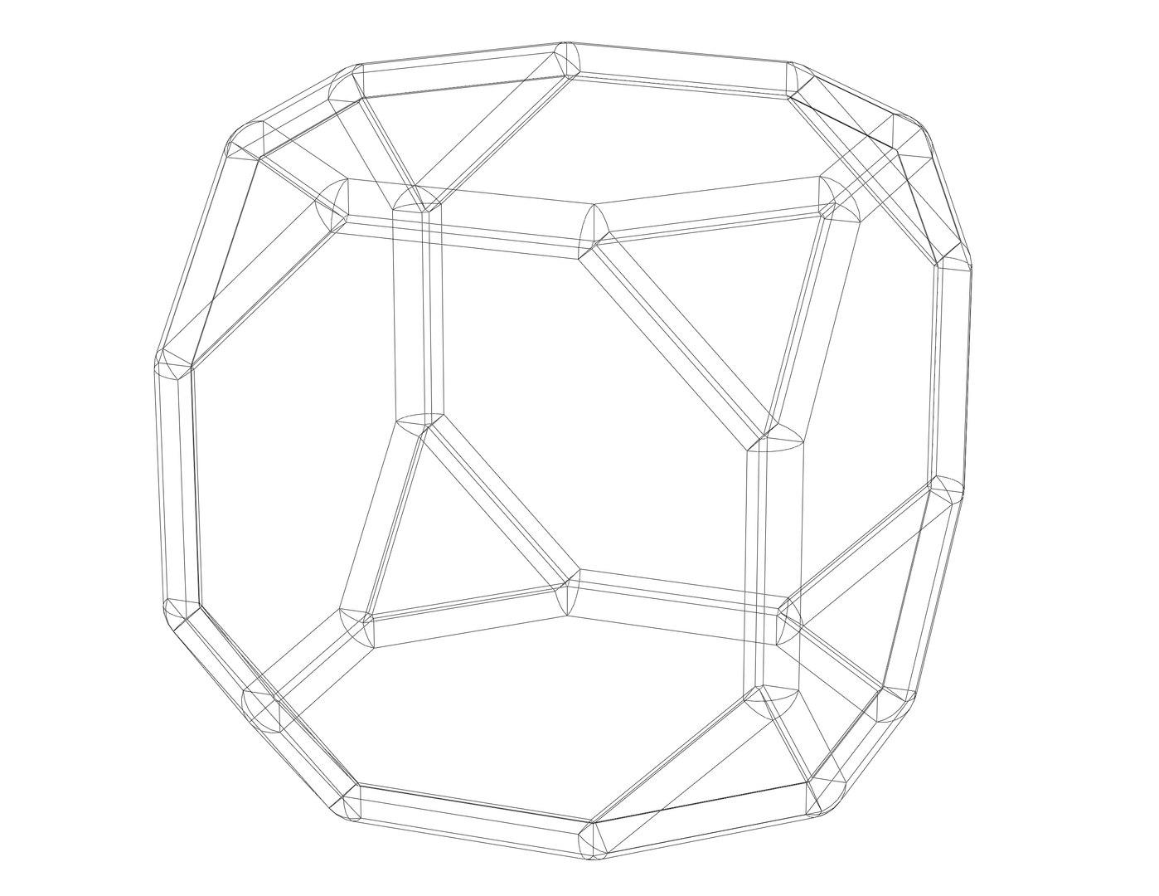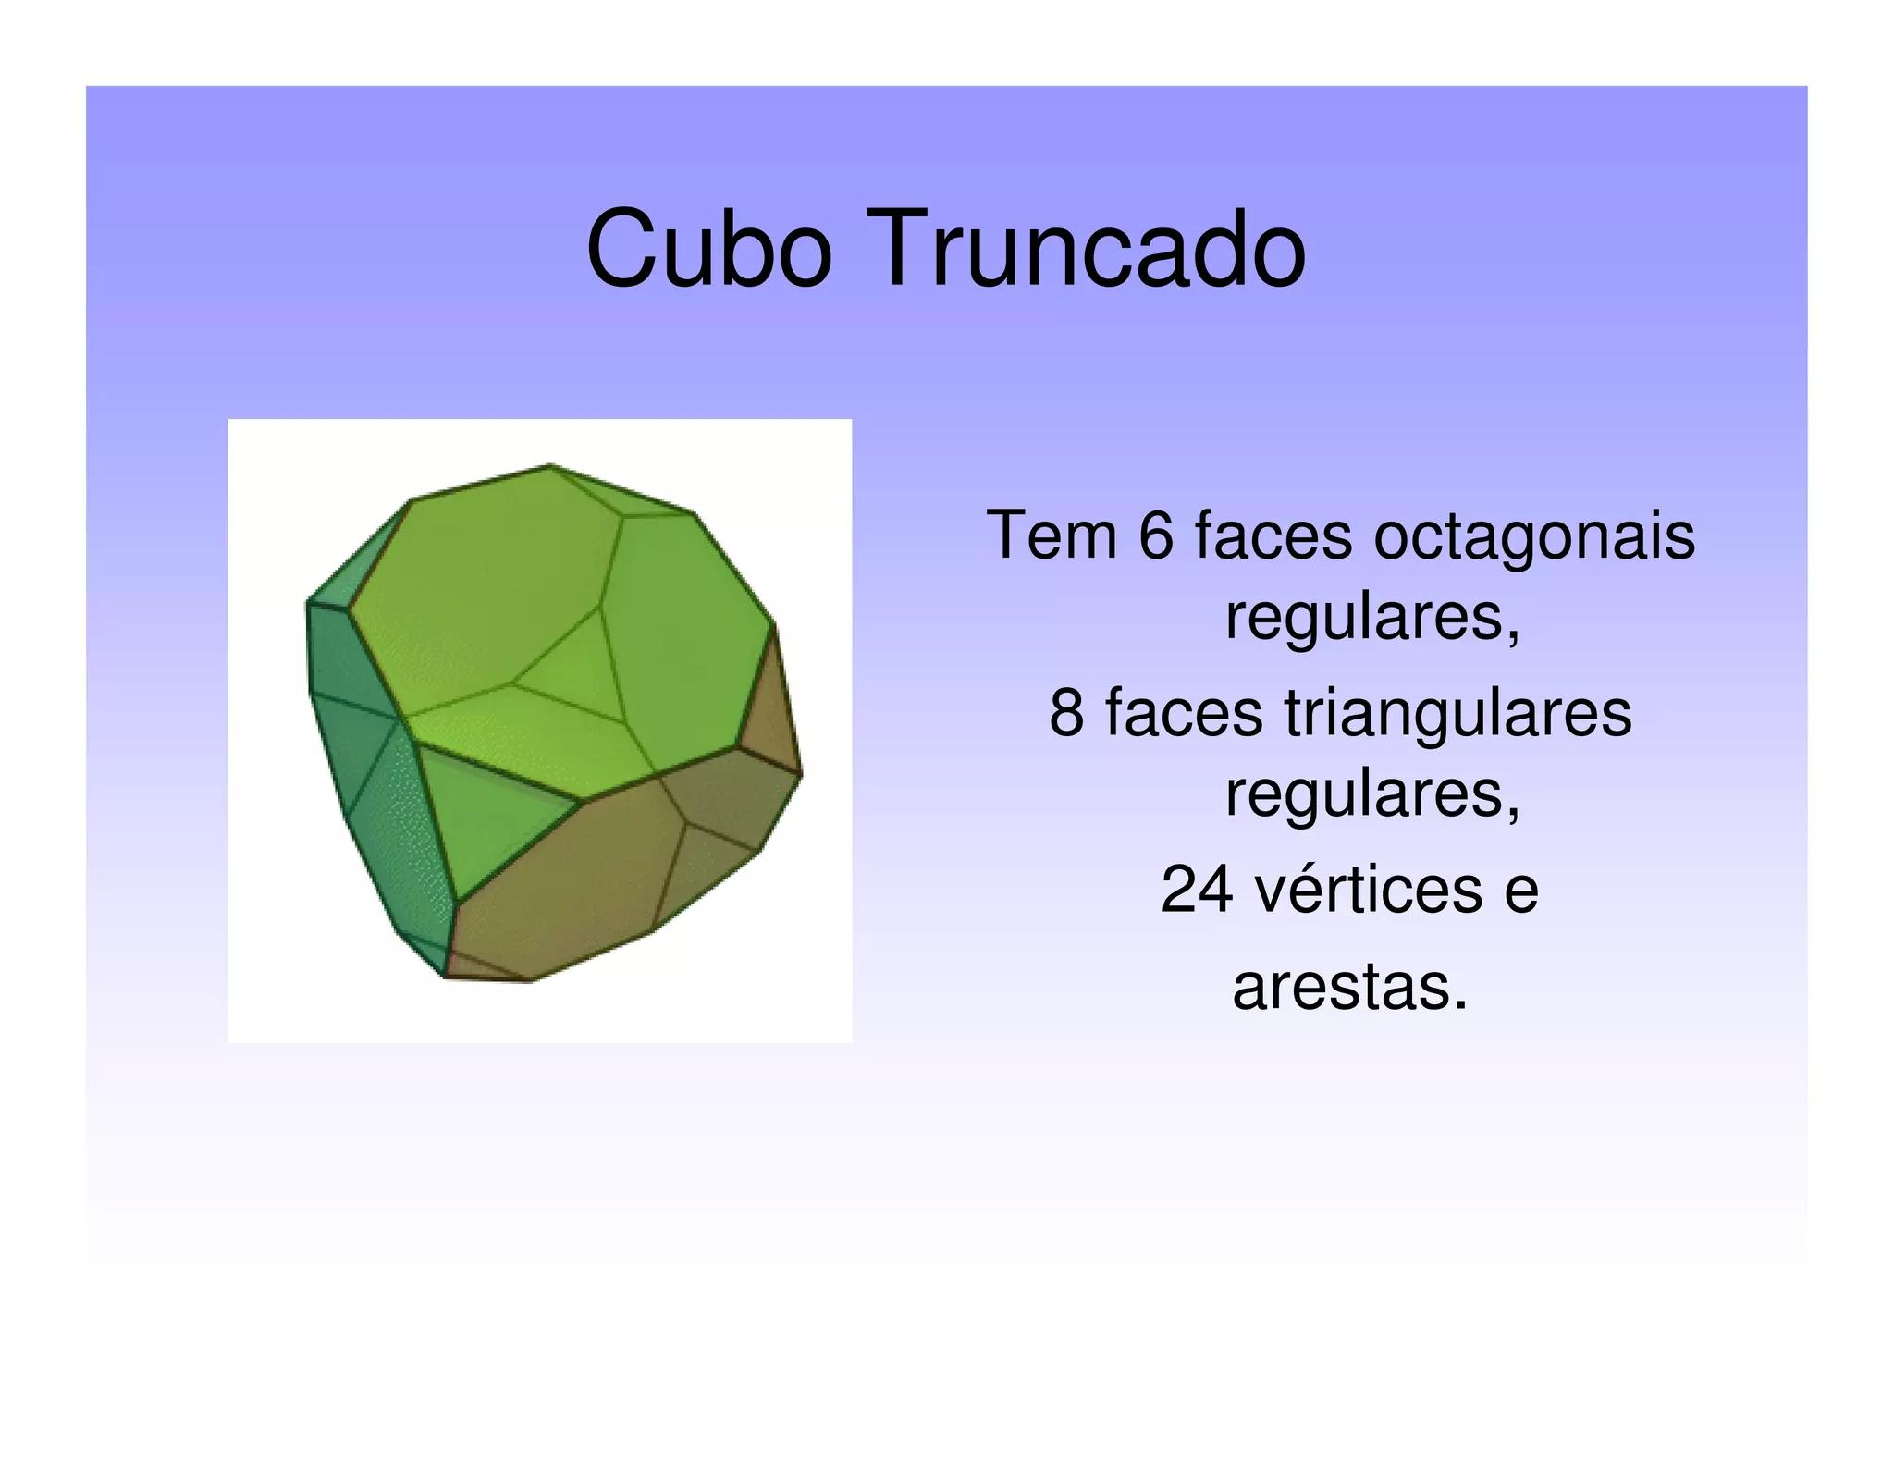

Definition
# Source: AI Source: Provided by: [Data Path: Persons Table -> ID Column: 1, Name_En Column: Motasem Essam] -> From: [ChatGPT] on [7/25/2026]
A Truncated Cube is a three-dimensional polyhedron formed by cutting off the eight vertices of an original cube using planes.
The truncation process creates new triangular faces while modifying the original square faces into octagons.

Geometric Characteristics
# Source: AI Source: Provided by: [Data Path: Persons Table -> ID Column: 1, Name_En Column: Motasem Essam] -> From: [ChatGPT] on [7/25/2026]
- Original Solid: Cube
- Original Vertices: 8
- New Faces: 8 triangles and 6 octagons.
- Total Faces: 14
- Total Edges: 36
- Total Vertices: 24

Face Structure
# Source: AI Source: Provided by: [Data Path: Persons Table -> ID Column: 1, Name_En Column: Motasem Essam] -> From: [ChatGPT] on [7/25/2026]
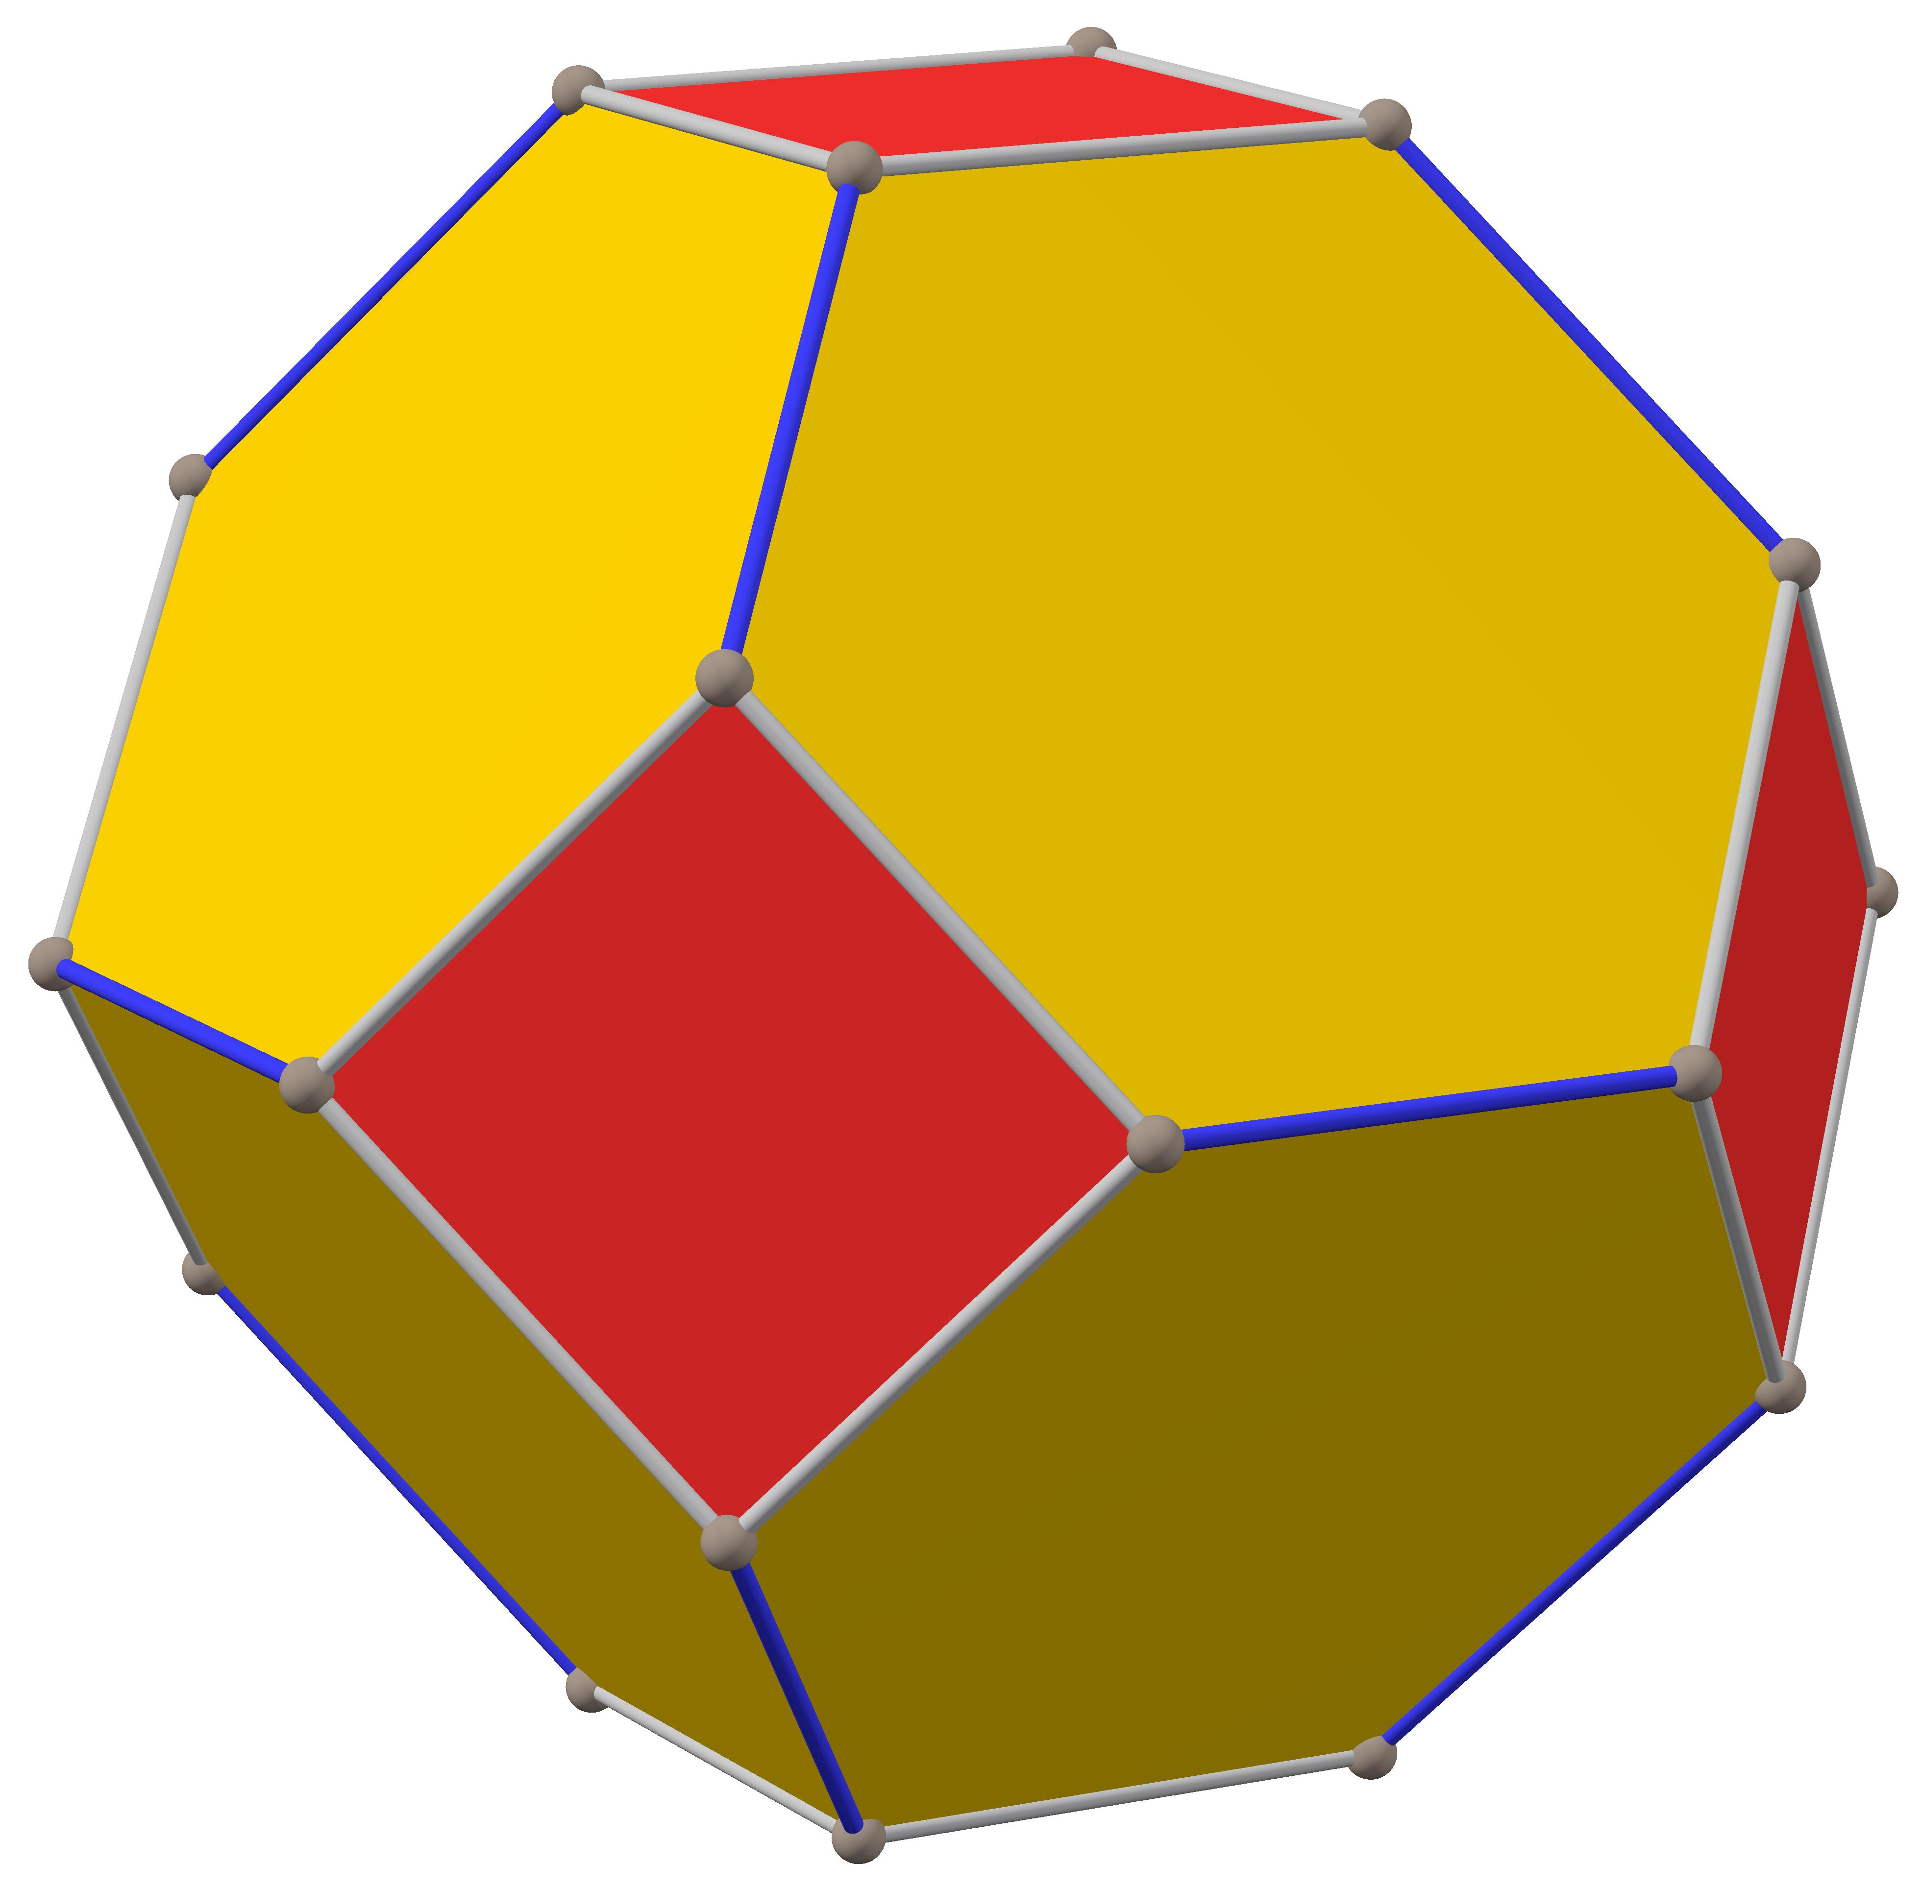
The truncated cube consists of:
- 8 Equilateral Triangular Faces: Created by cutting off the eight original vertices.
- 6 Octagonal Faces: Obtained by modifying the six original square faces of the cube.

Mathematical Properties
# Source: AI Source: Provided by: [Data Path: Persons Table -> ID Column: 1, Name_En Column: Motasem Essam] -> From: [ChatGPT] on [7/25/2026]
Let:
- $F$ = Number of faces
- $E$ = Number of edges
- $V$ = Number of vertices

Number of Faces
# Source: AI Source: Provided by: [Data Path: Persons Table -> ID Column: 1, Name_En Column: Motasem Essam] -> From: [ChatGPT] on [7/25/2026]
$$F=8+6=\boxed{14}$$

Number of Edges
# Source: AI Source: Provided by: [Data Path: Persons Table -> ID Column: 1, Name_En Column: Motasem Essam] -> From: [ChatGPT] on [7/25/2026]
$$E=\boxed{36}$$

Number of Vertices
# Source: AI Source: Provided by: [Data Path: Persons Table -> ID Column: 1, Name_En Column: Motasem Essam] -> From: [ChatGPT] on [7/25/2026]
$$V=\boxed{24}$$

Euler's Formula
# Source: AI Source: Provided by: [Data Path: Persons Table -> ID Column: 1, Name_En Column: Motasem Essam] -> From: [ChatGPT] on [7/25/2026]
For a convex polyhedron:
$$V-E+F=2$$
Substituting:
$$24-36+14=2$$
$$\boxed{2=2}$$
Therefore, the truncated cube satisfies Euler's formula.

Constructing Truncated Cube in Solid Geometry

Instruments Used
# Source: AI Source: Provided by: [Data Path: Persons Table -> ID Column: 1, Name_En Column: Motasem Essam] -> From: [ChatGPT] on [7/25/2026]
The construction uses physical geometric drawing instruments rather than coordinate-based construction.
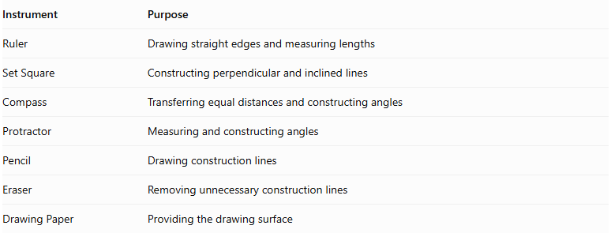
Instrument | Purpose
Ruler | Drawing straight edges and measuring lengths
Set Square | Constructing perpendicular and inclined lines
Compass | Transferring equal distances and constructing angles
Protractor | Measuring and constructing angles
Pencil | Drawing construction lines
Eraser | Removing unnecessary construction lines
Drawing Paper | Providing the drawing surface

Construction Procedures

A. Original Cube-Based Construction
# Source: AI Source: Provided by: [Data Path: Persons Table -> ID Column: 1, Name_En Column: Motasem Essam] -> From: [ChatGPT] on [7/25/2026]
This method starts with a cube and transforms it into a truncated cube.
- Draw a cube using an appropriate pictorial representation.
- Identify its eight vertices.
- Mark equal distances along the three edges meeting at each vertex.
- Construct triangular cutting boundaries around the vertices.
- Connect the marked points at each vertex to form the triangular truncation faces.
- Repeat the procedure at all eight vertices.
- Remove or visually suppress the original corner regions.
- Identify the six remaining octagonal faces.
- Darken the visible edges and distinguish hidden edges.
- Check that the resulting model has 8 triangular faces and 6 octagonal faces.

B. Edge-Based Construction
# Source: AI Source: Provided by: [Data Path: Persons Table -> ID Column: 1, Name_En Column: Motasem Essam] -> From: [ChatGPT] on [7/25/2026]
- Draw the original cube.
- Divide each cube edge according to the selected truncation distance.
- Mark the corresponding points on all twelve edges.
- Connect the marked points around each original vertex.
- Complete the triangular and octagonal face boundaries.
- Refine the final solid representation.

C. Face-Based Construction
# Source: AI Source: Provided by: [Data Path: Persons Table -> ID Column: 1, Name_En Column: Motasem Essam] -> From: [ChatGPT] on [7/25/2026]
- Draw the six square faces of the original cube.
- Mark the truncation points along the boundaries of each square.
- Connect the points to form an octagonal boundary inside each original face.
- Construct the triangular faces between adjacent octagonal faces.
- Join all face boundaries into one continuous polyhedron.

D. Net-Based Construction
# Source: AI Source: Provided by: [Data Path: Persons Table -> ID Column: 1, Name_En Column: Motasem Essam] -> From: [ChatGPT] on [7/25/2026]
- Draw a net containing six regular octagons and eight equilateral triangles.
- Arrange the faces so that their shared edges correspond correctly.
- Add tabs if the net will be used for physical assembly.
- Cut out the net.
- Fold along the shared edges.
- Join the corresponding edges to form the truncated cube.
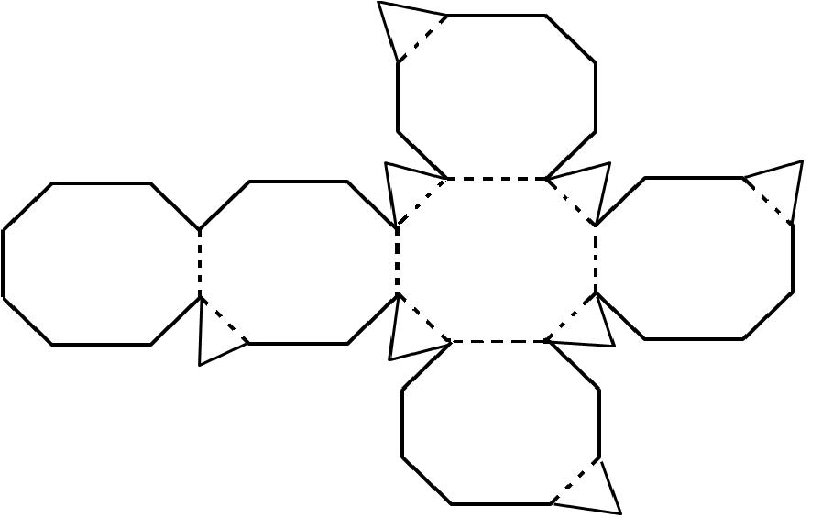

Key Points
# Source: AI Source: Provided by: [Data Path: Persons Table -> ID Column: 1, Name_En Column: Motasem Essam] -> From: [ChatGPT] on [7/25/2026]
- It is formed by truncating the eight vertices of a cube.
- It has 8 triangular faces and 6 octagonal faces.
- It has 14 faces, 36 edges, and 24 vertices.
- Each original vertex produces one new triangular face.
- Each original square face becomes an octagonal face.
- It is an Archimedean solid when uniformly truncated.

Conclusion
# Source: AI Source: Provided by: [Data Path: Persons Table -> ID Column: 1, Name_En Column: Motasem Essam] -> From: [ChatGPT] on [7/25/2026]
The truncated cube is a three-dimensional geometric solid obtained by cutting off the eight vertices of a regular cube. It consists of eight equilateral triangles and six regular octagons, creating a symmetrical solid with 14 faces, 36 edges, and 24 vertices.

